**Kalyani Government Engineering College**

Affiliated to

**Maulana Abul Kalam Azad University of Technology**

Department of Computer Application

Kalyani – 741235, Nadia, West Bengal



Project report on

**Web Designing and Development on Training and Placement Cell of KGEC**

Submitted by

Sutapa Maji 10271021034

Arijit Ghosh 10271021019

Niladri Shekhar Dutta 10271021012

Under the guidance of

Mrs. Arpita Nath

|  |  |  |
| --- | --- | --- |
| Phone: 25826680 (PBX)  Fax : 25821309 |  | Email: [contact@kgec.edu.in](mailto:contact@kgec.edu.in) |
| কল্যাণী – ৭৪১ ২৩৫  নদিয়া, পশ্চিমবঙ্গ |  | Kalyani – 741 235  Nadia, West Bengal, India  পত্রাঙ্ক/Ref. No.:  তারিখ/Date : |

**কল্যাণী গভঃ ইঞ্জিনিয়ারিং কলেজ**

**Kalyani Government Engineering College**

**(Govt. of West Bengal)**

***CERTIFICATE OF APPROVAL***

This is to certify that the project report on “Web Designing and Development on Training and Placement Cell of KGEC” is a record of project work under the curriculum of Maulana Abul Kalam Azad University of Technology (MAKAUT) for the 2nd year 3rd Semester Examination, 2022-23 for the subject “Minor Project and Viva-voce (MCAN-381)” carried out by 1. Sutapa Maji (Roll: 10271021034), 2. Arijit Ghosh (Roll: 10271021019), 3. Niladri Shekhar Dutta (Roll: 10271021012) the students of Kalyani Government Engineering College under the guidance of Mrs. Arpita Nath as a requirement for the partial fulfillment of the Degree of Master of Computer Application.

|  |  |  |
| --- | --- | --- |
| Head  Department of Computer Application  Kalyani Government Engineering College |  | Supervisor  Department of Computer Application  Kalyani Government Engineering College |

|  |  |  |
| --- | --- | --- |
| Examiner |  |  |

ACKNOWLEDGEMENT

We would like to express my special thanks of gratitude to our principal sir Dr. Sourabh Kumar Das, our HOD sir Dr. Surya Sarathi Das and our project guide Mrs. Arpita Nath ma’am who gave us this golden opportunity to make a project on the “Web Designing and Development on Training and Placement Cell of KGEC,” which also helped us in doing a lot of research and we came to know about so many new technologies.

Further, we would like to thank all our faculty members, without whom the project would not be completed within the stipulated time.

Finally, we would like to thank our friends and family for their abiding moral support.

|  |  |
| --- | --- |
|  | Arijit Ghosh  Roll: 10271021019 |

|  |
| --- |
|  |

DECLARATION

We declare that this written submission represents our ideas in our own words and where others’ ideas or words have been included. We have adequately cited and referenced the original sources. We declare that we have properly and accurately acknowledged all sources used in the production of this project.

We also declare that We have adhered to all principles of academic honesty and integrity and have not misrepresented or fabricated or falsified any idea/data/fact/source in our submission. We understand that any violation of the above will be a cause for disciplinary action by the institute and can also evoke penal action from the sources which have thus not been properly cited or from whom proper permission has not been taken when needed.

# OVERVIEW

The management of the Training and Placement Cell is currently supported by paper-based systems, databases, and email communications. The aim of this project is to automate the manual labor of Training and Placement Cell of KGEC. This is a web site which will help students, companies as well as the TPO to carry out placement related activities. The web site can be accessed from all devices using the proper credentials.

Every student and company will register themselves to the web site. The TPO will verify the well-grounded companies using the supporting document provided by the company. Afterwards, the companies will be able to post the placement drives. Soon after, the eligible students will be able to apply to those placement drives. The web site can be used as a platform by the TPO as well as the companies for managing student information of the placement drives.

INTRODUCTION

The use of the Internet and the World Wide Web has revolutionized the provision of information and the facility for the user to act on the information obtained. Use of the Internet to enable students and companies to manage the placement process with the active involvement of the Placement Coordinator. This led to a unique web-based training and placement management system. Online training and placement management systems provide information on placement providers and the placements they offer so that students may view and assess their opportunities. KGEC will have a well-developed website to inform their students of vacancies and how to prepare for their work-integrated learning experience. The online training and placement management system is an application to facilitate students in KGEC to register and fill out the application form. The users can access easily to this and the data can be retrieved easily in no time. In the student registration form, we can give personal details, educational qualifications, and professional skills. The job details of the placed students will be provided by the administrator. The job provider and the placements coordinator to take effective actions on the web as a follow on from the information they have viewed. The administrator plays an important role in our project. He provides approval of student registration and updating.

EXISTING SYSTEM

In the KGEC (Kalyani Government Engineering College) existing system led to many problems. These are as follows-

Problems in existing system -

* Maximum manual work: in the existing system all the work that is done by human intervention.
* Errors: due to the manual intervention there are maximum chances of errors.
* Maximum human interface: the interface between the student and administrator is maximum;
* Time consuming: due to above problems every procedure becomes time consuming.
* File system: the records were stored in modified access sheets hence sorting problem.
* No hierarchical: the files were not stored hierarchical format hence searching problems.
* Updating records: due to above problems the updating was very difficult and ambiguous;
* Duplication of files: due to above problems the duplication of records was usual hence data redundancy;
* Less alertness: the students may not get the information on training and placement activity hence they miss the opportunities.
* Synchronization problem: there were smaller amount interfaces among student and training and placement department;
* Alumni record: the past students records are not maintained.

PROBLEM DEFINITION

The existing system is doing all the processes manually. The administrator should refer all the records kept for years ago to simply know details. This so tedious and time consuming. This process is so difficult when the number of users increases There are a lot of limitations for the existing system. In manual Training and Placement all the work that is done at KGEC (Kalyani Government Engineering College) is by human intervention due to which there is a maximum chance of errors. The interface of student and a TPO is maximum which makes the system time consuming. At KGEC the records are stored in modified access sheets hence sorting is a problem. The files are not stored hierarchical format hence searching is a big problem due to this the updating is very difficult and ambiguous this leads to the duplication of records is usual hence data redundancy; The students are not being made aware of the Training and Placement activity hence there might have been loss of opportunities. The Access sheets were less optimized e.g. suppose we want students having 65% aggregate then the student with 70%, 75% aggregate are also selected whereas required result is only students with 65% aggregate. Others are not eligible. The system now at KGEC Training and Placement department could not take acknowledgement from the students attending to particular event hence lots of confusion at the last moment. There are fewer interfaces between student and Training and Placement department. There was no record kept of the past students. There is less communication between past or present student with the Training and Placement department.

MOTIVATION

* Automate candidate filtering
* Different candidate may see different jobs depending on the eligibility criteria.
* Reduce the paperwork and storage area.
* Improve the output of operators.
* Improve accuracy in result.
* Allow easy navigation through CV’s and company information.
* Manage the man and machine resources efficiently.

OBJECTIVES

* Automate the applying process of placement drives.
* Provide centralized database for all placement drives.
* Filter out eligible candidates.
* Provide a platform to companies to hire students.
* Reducing the gap between student and the Training and Placement Cell.

DESIGN DETAIL

In the online training and placement management System there are following module and their design details are as follows.

**Student Module:**

In the student module first, the student should get registered to the system by filling the placement registration form which contains the details such as name, date of birth, gender, address, email, mobile number and password. Once the student fills the placement registration form the account activation mail will be sent to the student’s email. After they can login to the system through the username and password and should fill the academic registration form. The application form will contain the details such as personal details and educational qualifications.

**Admin Module:**

The training and the placement officer are the administrator in the system. The administrator plays an important role in the project. In this module admin will login through username and password, once he logins he will be directed to the dashboard where he gets the complete details of every student of different courses and departments. The admin can add the newly added courses, departments and also can add new batch. The admin can also view the complete list of courses, departments, and batches. The admin can filter the students according to his needs through the search option, for example if the admin requires the student whose aggregate is greater than 65% in BE and greater than 70%in PUC and 10th. The admin is provided the option of search in which he can search the students using the name, mobile number, USN, Email, and registration ID. The admin is also provided with an option of sending bulk SMS and Emails. Administrator can send the bulk SMS and Emails to the students by filtering the students as he needs. Once the students submit the application form in the placement cell the placement officer can verify the details put up by the students. A unique registration ID will be generated for every student using this ID the placement officer can verify the students. The administrator also has the option of sending the templates to the students, it’s like if the student is eligible to the drive a template is sent to the students email with a unique registration ID, the students should take the print out of that template and should attend the placements.

**HR Module:**

The training and placement officer can also login to the HR section through the username and password. In this HR section all the information related to the HR’S are maintained. The placement officer can add the newly visiting company name to the database. The TPO can assign the company, assigning the company is nothing but in which year it is visiting, what’s the company criterion etc. The TPO should map the students, mapping the students is nothing but if the students get placed in some company the TPO should update the details such as in which company the student has been placed. The TPO can maintain all the HR’S information in this section by adding the details of the HR such as his name, mobile number, HR level, email, company name etc. The TPO can also maintain the information of other college TPO details. In this section the TPO have the option of maintaining the workshop or training details that are going to be held in the college. The admin can download all the details of the HR’s, placed students, training details, and all assigned companies in to the excel sheet.

IMPLEMENTATION

The term Implementation has different meanings ranging from the conversation of a basic application to a complete replacement of a computer system. The procedures however, are virtually the same. Implementation includes all those activities that take place to convert from old systems to new. The new system may be totally new replacing an existing manual or automated system or it may be major modification to an existing system. The method of implementation and time scale to be adopted is found out initially. Neat the system is test properly and at the same time, the users are trained in the new procedure. Proper implementation is essential to provide a reliable system to meet organization requirement.

DATA FLOW DIAGRAM

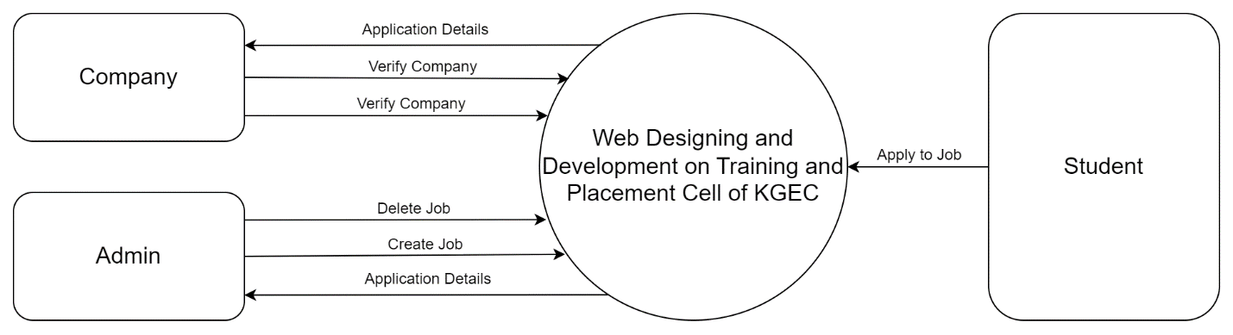

DFD LEVEL – 0

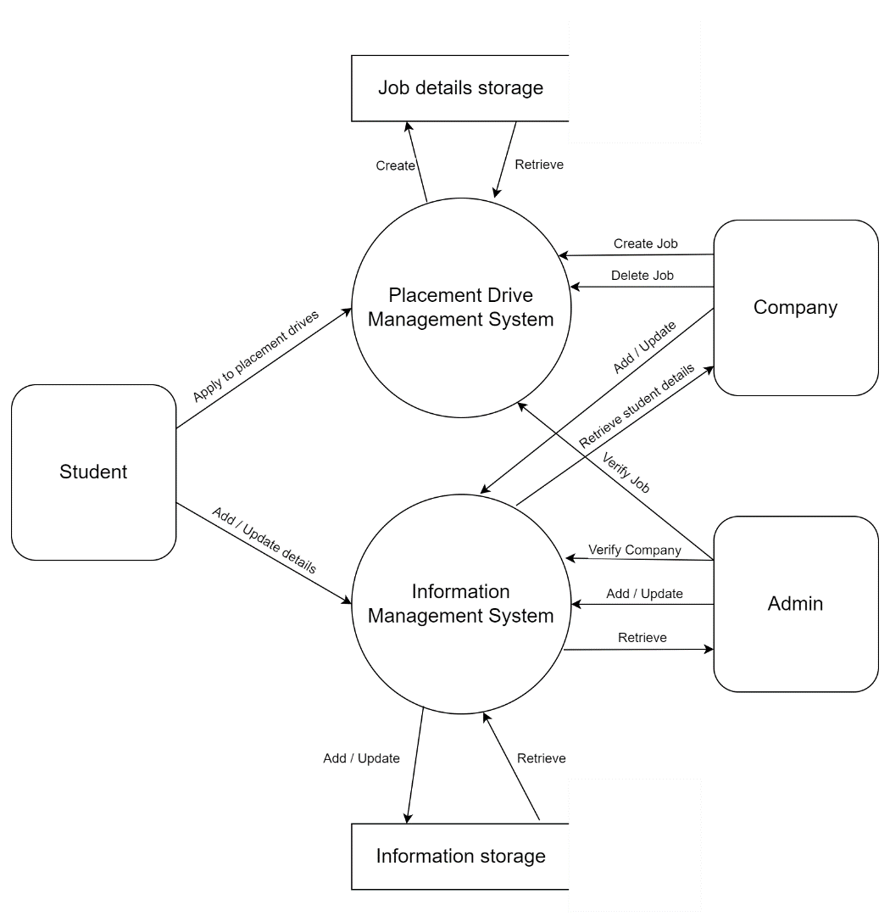

DFD LEVEL – 1

ENTITY-RELATIONSHIP DIAGRAM

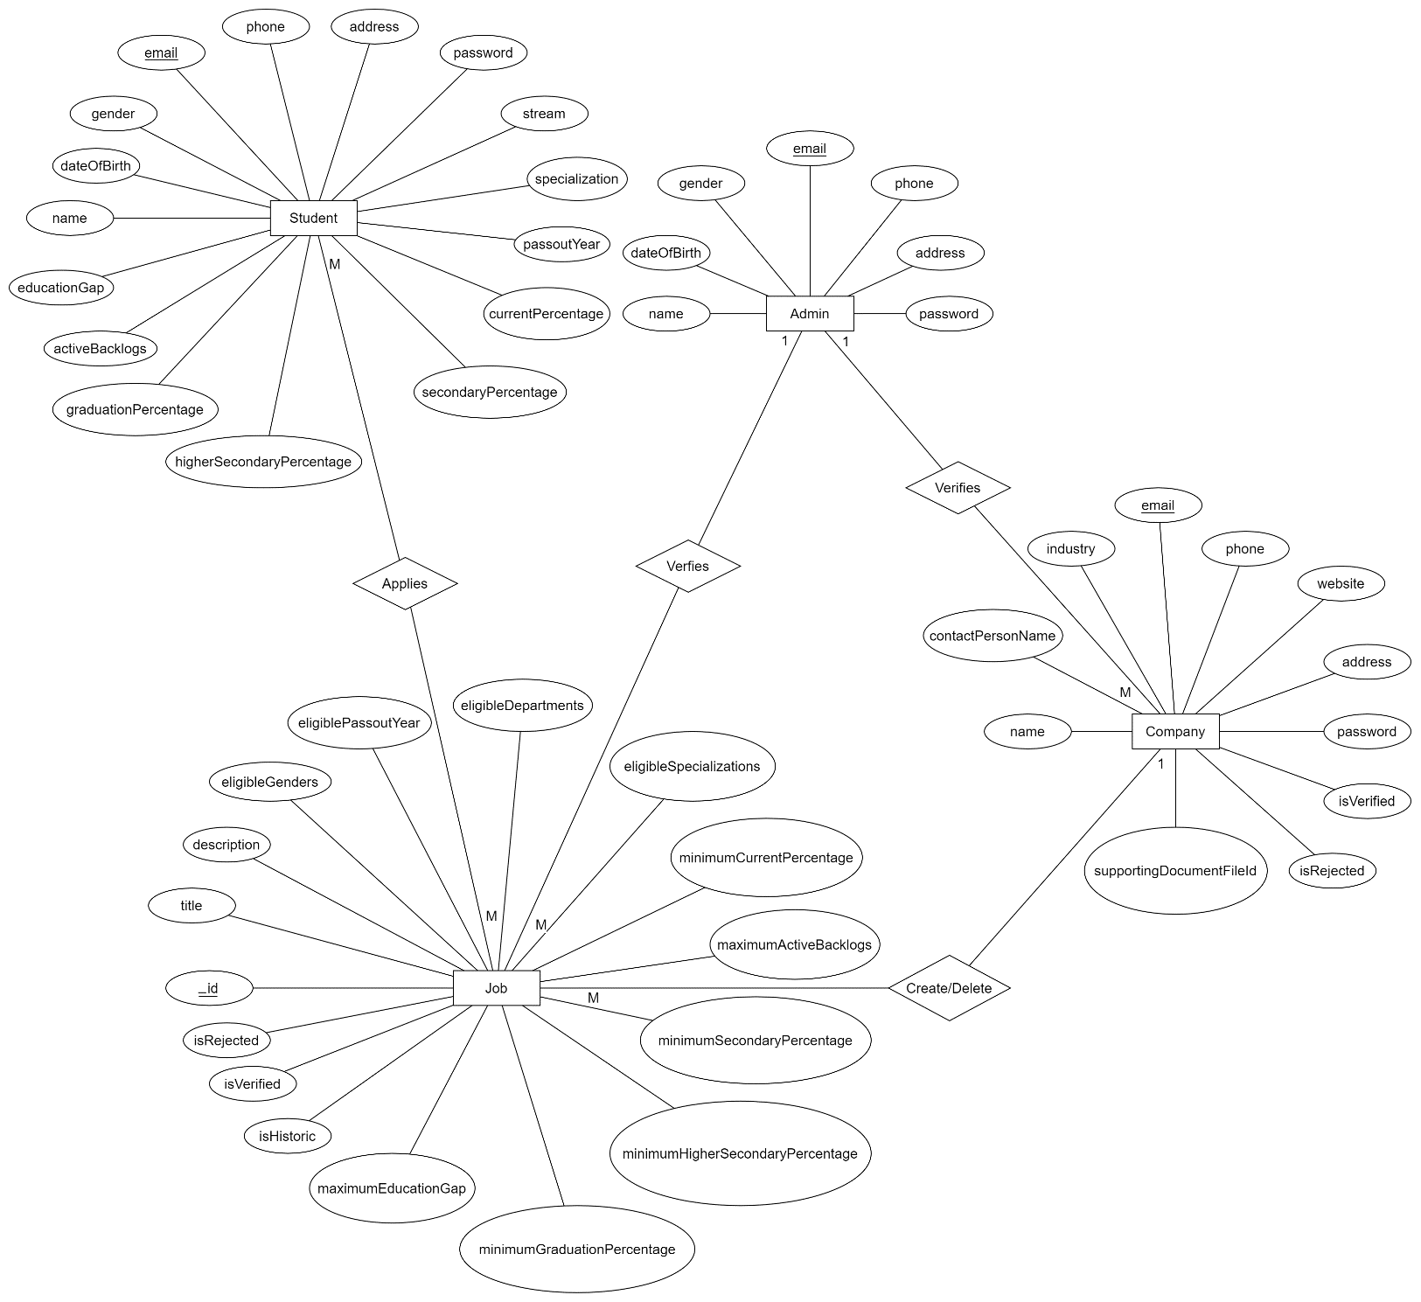USE CASE DIAGRAM

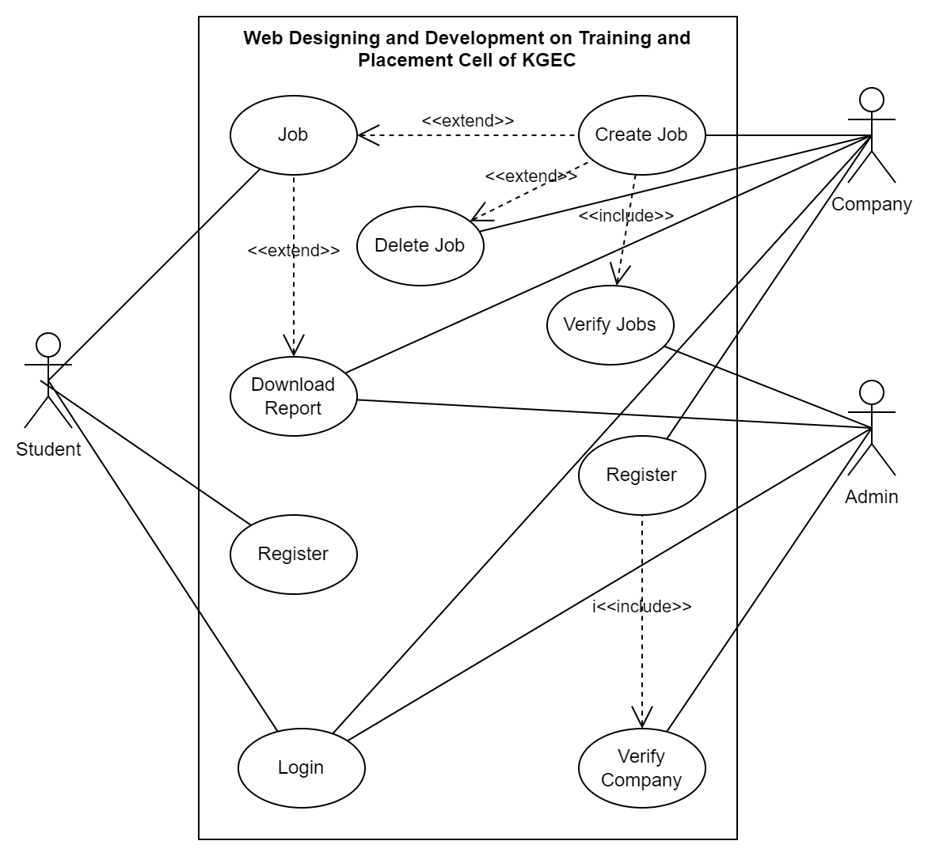

RESULTS

This is the home page of Training and Placement Cell of KGEC shown in Fig-1. Here company and students click on the buttons for register themselves.

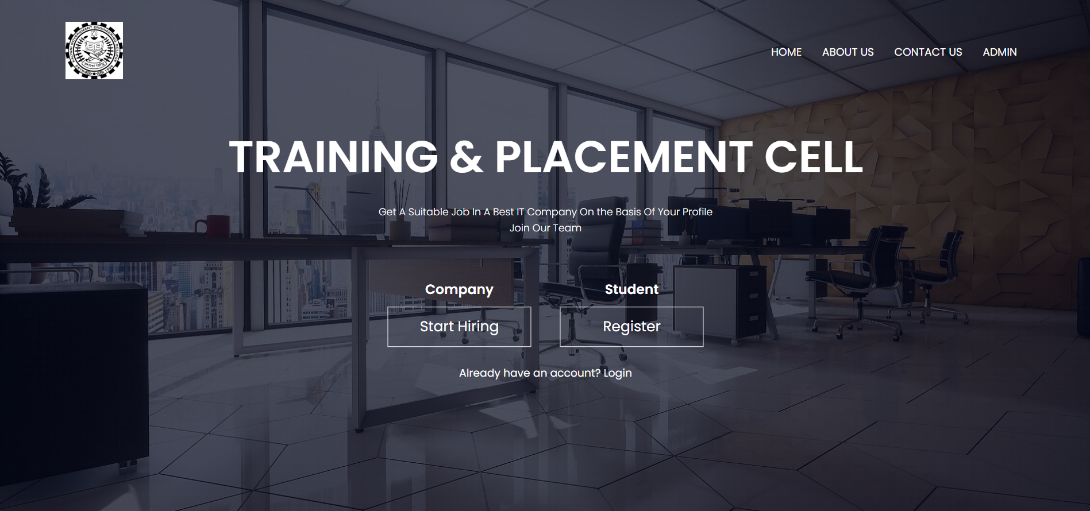

Fig -1: Home Page

The Registration Page for the Students of the Training and Placement Cell of KGEC is shown in the Fig-2. Students can fill the Registration form and after successfully registered they can sign into the student profile and fill the academic details.

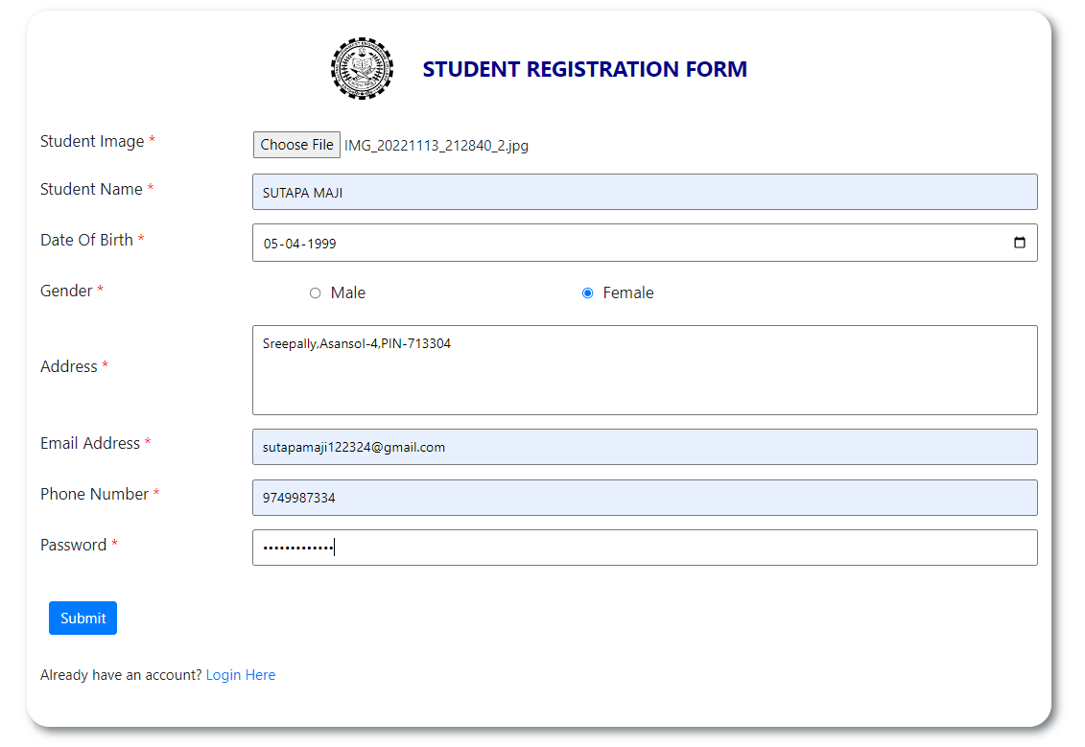

Fig-2: Student Registration Page

The Registration Page for the Company of the Training and Placement Cell of KGEC is shown in the Fig-3. The Company have to fill the Registration form once and after successfully registered a request mail sent to admin & after Admin verification they can sign into the company profile and post their jobs. For the same company will not have to register in the next year.

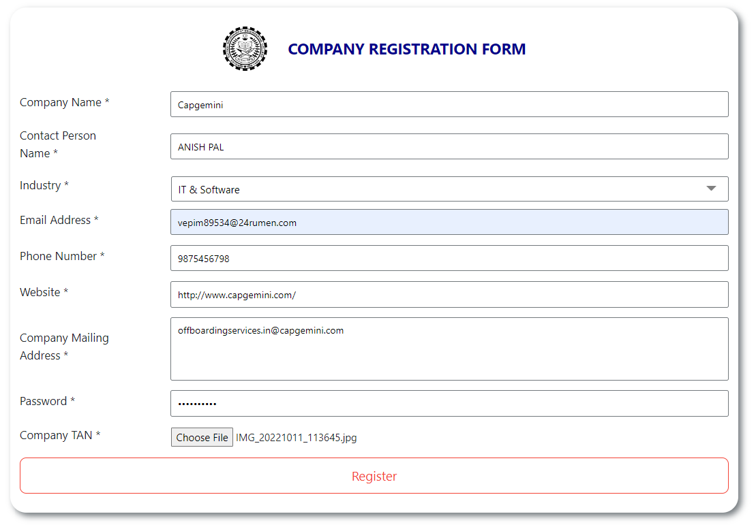

Fig-3: Company Registration Page

The Login Page of the Training and Placement Cell of KGEC is shown in the Fig-4. The Student & Company can login to the system by using this login form.

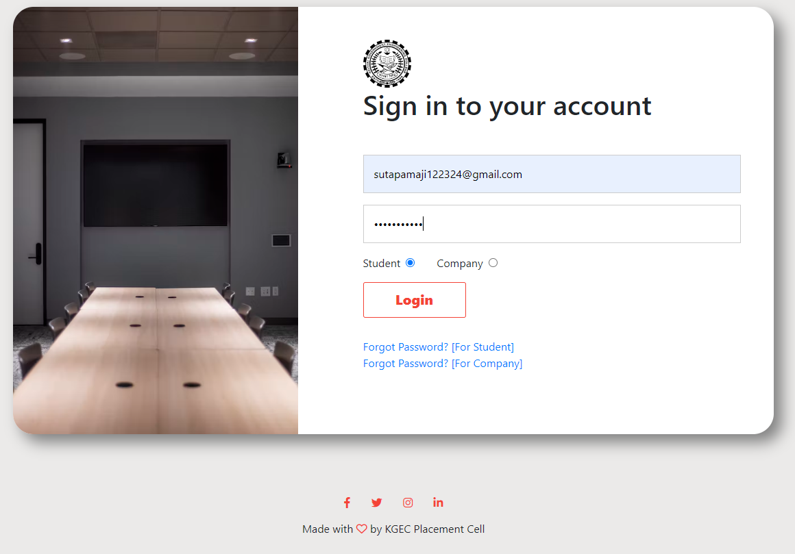

Fig-4: Login Page

The Student Profile of the Training and Placement Cell of KGEC is shown in the Fig-5. After login Student have to fill their academic details & according to their profile, they can see job posts.

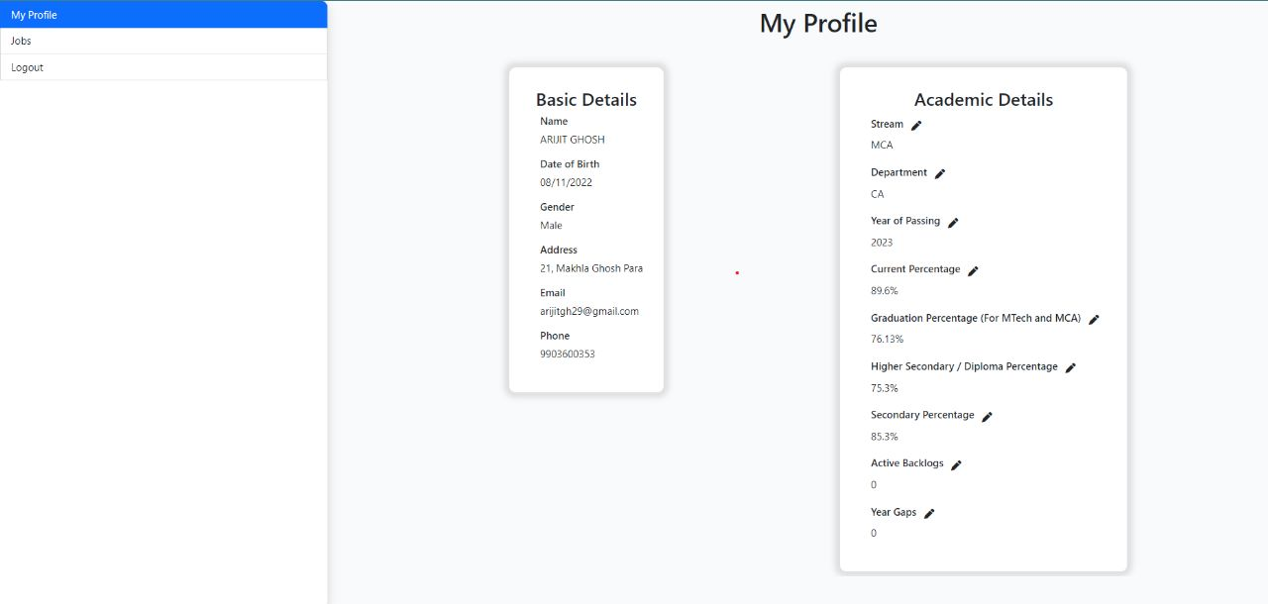

Fig-5: Student Profile

The Company Profile of the Training and Placement Cell of KGEC is shown in the

Fig-6. After login HR can do all the necessary work like they can post and update jobs.

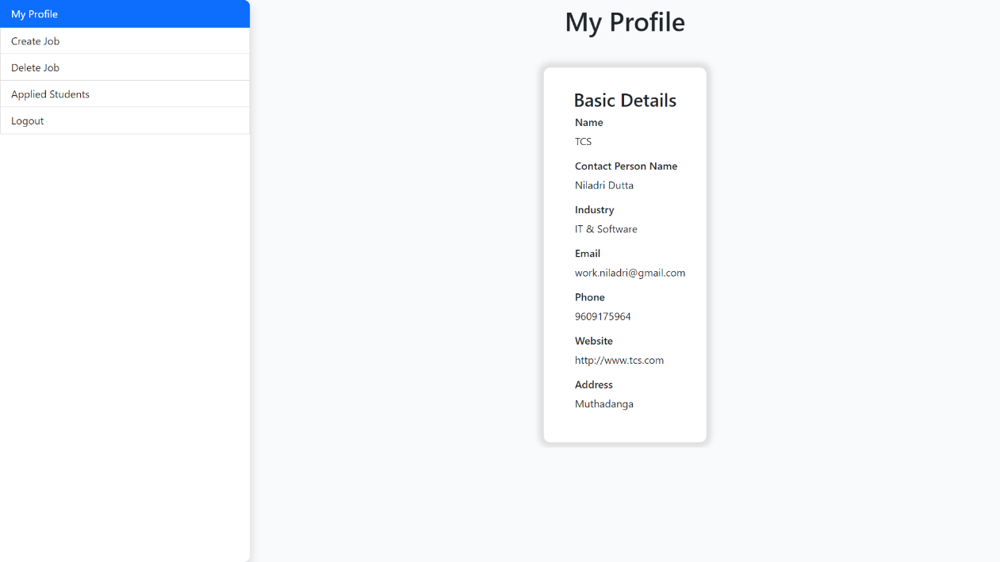

Fig-6: Company Profile

The Admin Login Page of the Training and Placement Cell of KGEC is shown in the Fig-7.

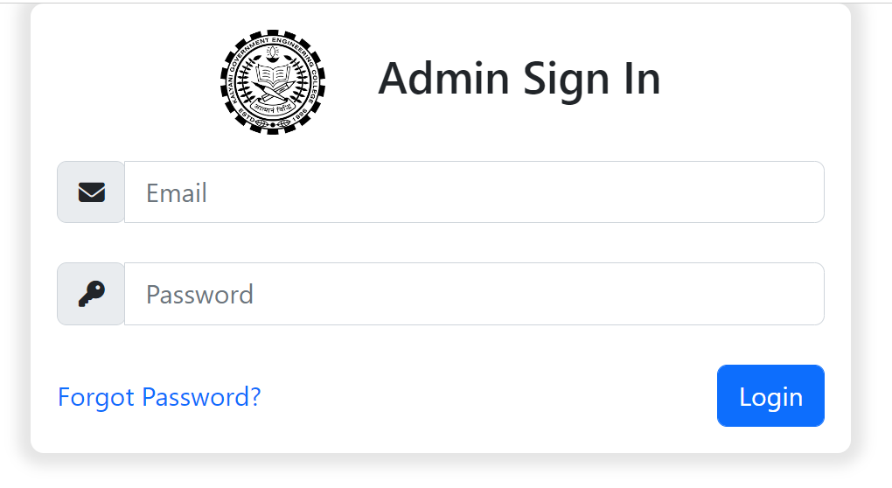

Fig-7: Admin Login Page

The Admin Profile of the Training and Placement Cell of KGEC is shown in the Fig-8. After login Company can post, update jobs. The admin can do all the necessary work in the options provided to him related to HR’s, placed students and training details.

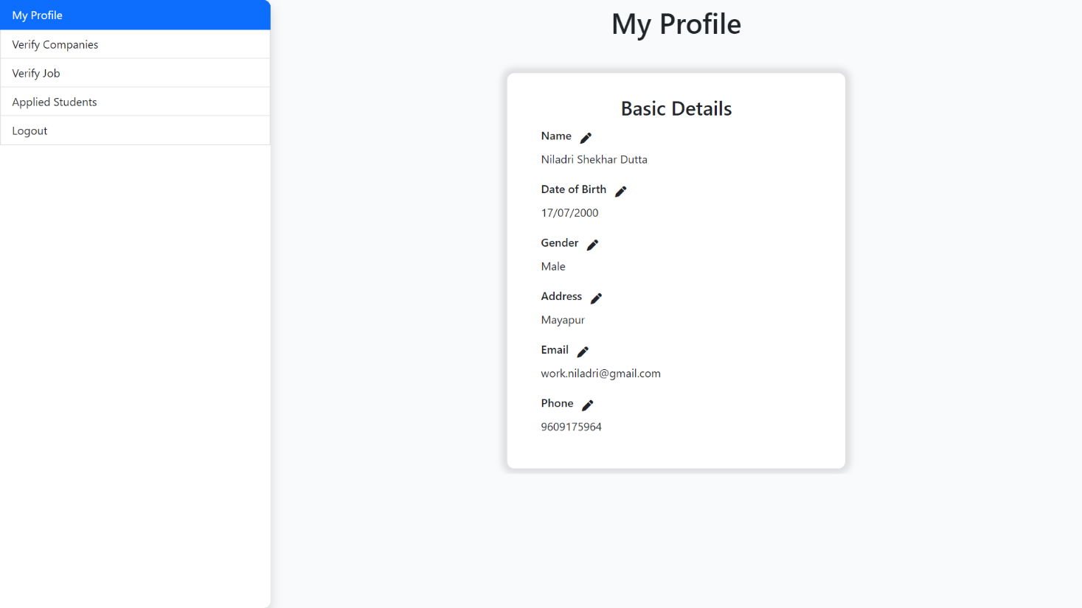

Fig-8: Admin Profile

INNOVATIONS

In this website, students will register here once only. At the placement session according to their resume or qualification criteria they will get notification of preferable jobs.

Also, to hire students, company will also register only 1 time and after login they will create different jobs with required qualification and skills.

LIMITATIONS

* Currently the placement drives cannot ask any additional questions.
* Admin can’t update or block students who will get more than 1 on-campus job.
* Currently there are no training or mock test facility available here.

FUTURE SCOPE

It will provide different dynamic questions to placement drive. Also beside get the job, students will get training session that how they face and crack different interviews. For practice our placement drive provide mock test to the students that which type of aptitude questions or coding questions company asks. Admin will update and delete record of student who will be getting jobs by on campus.

CONCLUSION

In the existing system maximum work goes manually and it is error prone system, takes time for any changes in the system. The big problem is the searching and updating of the student data and also no any notification method available for giving information to student expect the notice board. The proposed Training and Placement Cell system gives the automation in all the process like registration, updating, searching. It provides the detail solution to the existing system problem. The main aim of the Training and Placement cell website is to reduce the communication gap between Placement Officer and the students. Students can update their information effortlessly and independently. Also, the users can access the application online easily at any time. This application reduces the manual work and tedious accessing of web portal. Since majority of users use phones and laptops, the Training and Placement Cell is developed using web technologies. This website is very user friendly, secure and easy to access by all authorized members.

REFERENCES

[1] Talaba, D., Moja, A, Zirra, E., Guidelines towards a European standard for quality assurance of student placement, available in login space on www.q-planet.org.

[2] Zirra E., March F., Building University - Enterprise Cooperation for the Benefit of Students, Enterprises and Companies. EUI-Net workshop, Athens 28 September (2006). http://www.eui-net.org/Project_documents/.

[3] Tynjδlδ, P., Perspective into learning at the workplace, Educational Research Review, 3,2008, pp.130-154.

[4] Training and Placement Department of Rajiv Gandhi Institute of Technology